Understanding Survey Data: Digital Consultation with the Victorias City Youth

Executive Summary:
In partnership with Makati Business Club and The Asia Foundation, Victorias City conducted an online consultation with its youth constituents to understand how it can best support the youth through more holistic and inclusive mental health care support. The digital consultation lasted from September 20 until October 5, 2022, wherein a total of 405 voters ages 15-30 years old in Victorias City participated.
After the data collection process, the survey data collected has undergone a data-science and Natural Language Processing (NLP) approach to analyze and gain insights from the data. In the analysis of the vote, the most voted cause of stress of the participants is friends, family, and romantic relationships. Apart from the mentioned main stressors, other sources of stress were mined from the most frequent words that appeared in the participants’ comments, which are social media, appearance, public speaking, bullying, finances, and academics/schoolwork.
To further understand the comments of the participants on the open-ended question that aims to know the other source of stress. Thematic analysis has been conducted using the Gibbs Sampling Dirichlet Multinomial Mixture (GDSMM), to identify the underlying themes based on the participant’s comments. In this analysis, (4) central themes were obtained:
- Family problems
- The impact of social media
- The Uncertainty of tomorrow
- Typical daily struggles
Also, based on the analysis, the participants are more likely to tell a friend or family rather than consult a mental health professional when experiencing a mental health issue. Additionally, the participants are more likely to tell on someone if they see people experiencing mental health issues compared to when they experience it themselves. The most voted intervention/program in terms of mental intervention is an awareness campaign, followed by therapies and counseling.

Backgrounds of The Survey:
Victorias City conducted an online consultation with its youth constituents to understand how it can best support the youth through more holistic and inclusive mental health care support. The survey findings will benefit the local government in developing plans and implementing programs for the mental health of the youth.
Objectives of the Survey:
- Identify the main cause of stress of the participants, per gender and per age range
- Understand the other cause of stress of the participants based on their comments
- Determine the tendencies of the participants when experiencing mental health issues; and,
- Highlight the top-voted mental health intervention according to the Victorias youth constituents
Methodology:
Victorias City conducted an online survey targeting youth constituents. Below is the high-level flow of the feedback collection and analysis process.
Feedback Collection Process and Instruments
The primary collection tool used was the website (mbc.com.ph), wherein the respondents answered a survey questionnaire consisting of (3) sections: personal information, voting/ranking types of questions, and an open-ended comment section. The personal information consists of name, age range, gender, current educational attainment, and whether the person is a resident of Victorias City. The voting/ranking section is the type of question where respondents can rank the source of stress, select the tendencies of the participants when experiencing mental health issues and vote on the mental health intervention that should be prioritized. Also, there is an open-ended feedback part of the questionnaire wherein respondents can input comments such as the other source of stress and other mental health intervention.
Feedback Collection Summary
Below is a summary of the feedback collection process:
Target Respondents | Youth Respondents
Opening Citizen Assembly | September 20, 2022
Closing Citizen Assembly | October 5, 2022
Days of Feedback Collection | 15 days
Number of Individual Voters | 405 voters
Number of Statements | 30 statements
Numbers of Qualitative Feedback Received | 343 comments

Metadata: Demographics of the Respondents
Fig 1. Age Range of the Participants |  |  | Fig 2. Gender of the Participants
Fig 3. Educational Attainment of the Respondents

Based on the demographics, most of the respondents of this survey are in the age range of 15-18 and are currently in either junior or senior high school. In terms of gender, more than half, or 60% of the participants are female. Also, the majority of the participants are Victorias City residents.

Table 1: SUMMARY OF VOTES

 | Statements | At no time | Some of the time | Less than half of the time | More than half of the time | Most of the time | All the time
 | I have felt cheerful and in a good spirit | 19 | 43 | 66 | 99 | 103 | 43
 | I have felt calm and relaxed | 23 | 99 | 87 | 103 | 69 | 24
 | I have felt active and rigorous | 20 | 82 | 87 | 94 | 80 | 42
 | I woke up feeling fresh and rested | 52 | 96 | 96 | 81 | 47 | 33
 | My daily life has been filled with things that interest me | 28 | 81 | 98 | 75 | 70 | 53
The table above shows the summary of the votes of the participants on the question ‘how you have been feeling over the last two weeks?’ To group the participants based on their response, the votes from the at no time, some of the time, less than of the time column has been computed and regarded as group negative. On the other hand, the positive group is from the more than of the time, most of the time, and all the time columns. By computing the percentage of votes, the group positive is 76% of the participants while only 24% of the participants are in group negative. This may indicate that majority of the participants are in positive feelings over the past two weeks.
Source of Stress – Votes Analysis
In this analysis, the respondents' votes ranking the cause of stress are measured by getting the average mean per stressor. In the survey, 1 is the highest rank. Thus, the lower average scores indicate a higher rank. The tables below show the result of the voting analysis.
table 2: the main Source of stress
Rank | Cause of Stress | Score
1 | Friends | 1369
2 | Family | 1608
3 | Romantic Relationships | 1642
4 | Other students at school | 1664
5 | Other youth online | 1840
6 | Work | 2104
7 | Physical Health | 2148
8 | Finances | 2454
9 | School Work | 2541

table 3: the main cause of stress per gender
Rank | Male | Female
1 | Friends | Friends
2 | Family | Romantic Relationships
3 | Other students at school | Other students at school

Table 4: the main cause of stress per age range
Rank | 15-18 | 19-21 | 22-25 | 26-30
1 | Friends | Family | Other students at school | Family
2 | Romantic Relationship | Friends | Family | Friends
3 | Other students at school | Other students at school | Friends | Romantic Relationship

Based on the analysis of votes from the cause of stress of the participants, the top (3) stressors are friends, family, and romantic relationships. This may indicate that the main source of stress in Victoria’s youth is more on the relationship aspect rather than situations or another aspect of life. In table 3, the side-by-side comparison of the stressor per gender is shown. It can be seen that both gender relatively have the same top stressor except for rank 2 wherein the male participants’ rank 2 stressor is family, while, the female rank 2 stressor is romantic relationships. The comparison per age range is relatively similar to the findings seen in tables 2 and 3.
Mining Insights from the Qualitative Data
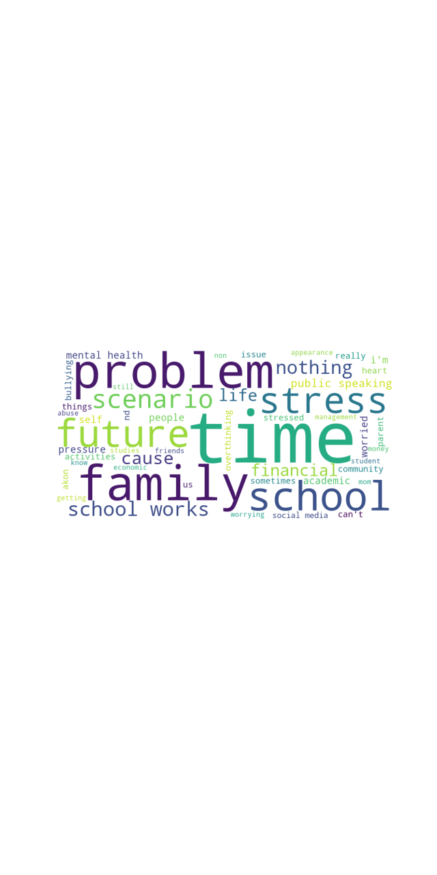
Apart from analyzing the vote, the respondents also added comments in an open-ended format regarding the other source of stressors. From the textual comments, key topics were obtained using Natural Language Processing (NLP). The figure above shows a word-cloud visualization of the most frequent words from respondents' comments revealing other stressors that affect the Victorias youth’s mental health. The following are the key stressors mined from the textual data:
- Worrying and pressure for the future
- Family
- Public Speaking
- Appearance
- Bullying & Abuse
- Self-studying, schoolwork, and academics
Thematic Analysis
To further understand the textual inputs of the respondents for the other cause of stress. Thematic analysis through the Gibbs Sampling Dirichlet Multinomial Mixture (GDSMM) was utilized in this analysis. GDSDMM is a short text clustering model. The model groups words into a cluster like each other based on usage and meaning.
This analysis aims to determine the other cause of stress or the factors that contribute negatively to the mental health of the Victorias youth participants.
Table 5: Central Themes Obtained from Thematic Analysis
Topic # | Label | Topic Words
1 | Family Problem | family, overthinking, heart, problem, needs, parent
2 | The Impact of Social Media | scenarios, stress, causes, social, media, economic
3 | The Uncertainty of Tomorrow | worried, future, stressed, cause, life
4 | Typical Daily Struggles | School, works, financial, problems, money

The central themes obtained in the general perspective based on the comments are seen in Table 5. The first theme is labeled as 'Family problem’ which is supported by topic words like ‘family, overthinking’, ‘problem’, ‘needs’, and ‘parent’. This may entail that the primary source of stress or factors that contribute to the mental health issues of the participants is the familial problem. This is a concern as families should be the support of the youth, yet in this case, it is evident from the comments that families are the ones causing problems to the mental health of the youth. Another topic obtained is labeled as ‘The impact of social media’ with supporting terminologies like 'scenarios’, ‘stress’, ‘causes’, ‘social’, and ‘media’. This topic was not seen in the given choices from the voting part of the survey; however, it became apparent that it is also one of the primary stressors of the youth in Victorias city. It could be about the social media pressure, the trying-to-fit-in concept wherein most young people want to achieve or do what they see on social media. The third topic obtained is the ‘Uncertainty of tomorrow’ wherein words like ‘worried’, ‘future’, ‘stressed’, ‘causes’, and ‘life’ were shown. This is a prevalent issue with young people as they are worried about life and the future, which could be about what course they will take in college, what career to pursue, and other reasons which may affect the mental health of the youth. Lastly, the topic about ‘the typical daily struggles’ which are supported by terms like ‘school’, ‘work’, ‘financial, ‘problems’, and ‘money’. This topic is evident in the daily life of Filipinos, struggling with work, school, and finances is one of the primary causes that affect the mental well-being of Victorias youth.
Participants Tendency – Votes Analysis
Table 6: Summary of Votes
Tendency Statement | Not at all | Very Unlikely | Likely | Very Likely
Talk to a friend | 36 | 83 | 175 | 111
Talk to a family | 87 | 100 | 106 | 112
Talk to a teacher | 126 | 127 | 103 | 49
Consult a mental health professional | 146 | 88 | 107 | 64
Check online resources | 73 | 95 | 140 | 97

Table 6 above shows the summary of the votes in the question ‘If you are experiencing a mental health issue (feeling anxious, depressed, suicide thoughts), how likely are you to:’. From the votes, it can be seen that participants are more likely or very likely to talk to a friend or family when experiencing mental health issues rather than consulting a mental health professional. 62% of the participants are more likely to talk to a friend/family and only 15% are very likely to consult a mental health professional. This could imply that there is a challenge/gap in seeking help from a medical professional, it could also imply accessibility issues, costly medical fees, and other reasons. Also, as seen from the results, participants are more likely to seek knowledge or advice from online resources than consult a professional.
Table 7: Summary of Votes
Tendency Statement | Not at all | Very Unlikely | Likely | Very Likely
Tell to his/her friend | 40 | 83 | 158 | 124
Tell to his/her family | 55 | 88 | 132 | 130
Tell to his/her teacher | 83 | 103 | 144 | 75
Consult a mental health professional | 74 | 74 | 126 | 131
Check online resources | 62 | 72 | 137 | 134

Table 7 above shows the summary of the votes in the question ‘If you know someone experiencing a mental health issue (feeling anxious, depressed, suicide thoughts), how likely are you to:’. Based on the analysis of the results from tables 6 and 7, the participants are more likely to tell someone if they see people experiencing mental health issues in comparison with if they are experiencing it themselves. This could imply that Victorias youth participants are not reluctant to tell someone and are willing to listen once they know someone is experiencing a mental health issue.
Mental Health Intervention – Votes Analysis

Based on the votes on the mental health interventions, the most voted programs are awareness campaigns and therapies. and counseling. The most voted program is the awareness campaign with 308 votes, this may imply that the participants acknowledge that not everyone is knowledgeable the mental health issues, thus, this awareness campaign can help attribute to creating more interventions for mental health. Although, the most voted awareness campaign each intervention as seen in the chart above, obtained a decent number of votes which may indicate that each program can be helpful in addressing the mental health issues of the Victorias City youth. The implementation of each mental health program can help support Victorias youth in a more holistic and inclusive manner.
ANALYSTS FOR THIS REPORT:
Myron Darrel Montefalcon, Mideth Abisado
National University National University

Jay Rhald Padilla Ramon Rodriguez
National University National University
END OF REPORT
Revised: 10/17/2022

